Software Requirement Specifications
Project Title: GlowHub – Imported Makeup & Beauty Store for Pakistan



Submitted by
(Hina Majeed )
(F22BINFT1M01168)

Submitted to
(Ms.Sara Fareed)

Department of Information Technology
Faculty of Computing
The Islamia University of Bahawalpur

SUMMARY

This Software Requirements Specification (SRS) defines the design and functionalities of GlowHub – Imported Makeup & Beauty Store for Pakistan, a web-based e-commerce platform that enables users to purchase authentic international beauty and skincare products online. The system is designed to provide a secure, localized, and user-friendly shopping experience with key features such as PKR-based pricing, pre-order options, and multiple secure payment methods including JazzCash, EasyPaisa, and bank transfers. It also includes a bilingual interface, an admin dashboard for product and order management, and real-time order tracking through courier integrations.
Built using modern technologies such as React.js for the frontend, Node.js or Django for the backend, and MongoDB/MySQL for database management, GlowHub ensures high performance, scalability, and reliability. This document serves as a detailed guide for developers, designers, and stakeholders throughout the development process, ensuring that the final product delivers a trusted, efficient, and seamless e-commerce experience tailored to Pakistan’s growing beauty market.

Table of Contents

1.1. Purpose 4
1.2. Scope 4
1.3. Product Perspective 5
1.4. User Characteristics 6
1.5. Similar apps and systems/Literature Review 7
1.6. Proposed Technologies 11
2. Requirements 11
2.1. Function Requirements 12
2.1.1. Sign Up 12
2.2. Non-Functional Requirements 12
3. Use Cases and Flow of Processes 12
3.1. Use Case 1 13
3.2. use case 2
3.3. use case 3
4. References 14

1: Introduction
  - Purpose
The purpose of this Software Requirements Specification (SRS) is to define the overall requirements and functionalities of the GlowHub platform. The document aims to provide a comprehensive understanding of the system for developers, designers, project managers, and stakeholders.
The SRS specifies:
- The purpose and functionality of the system.
- The intended users and their characteristics.
- The product environment and constraints.
- The functional and non-functional requirements of the system.
- The use cases and workflow for core operations.
This document serves as a blueprint for system development and ensures all project contributors share a unified understanding of the system objectives. It will be used as a reference throughout the design, development, testing, and deployment phases.

  - Scope
GlowHub is a web-based e-commerce platform that allows users in Pakistan to explore and purchase authentic imported makeup, skincare, and fragrance products. The system will provide a convenient online store for international brands such as Fenty Beauty, Huda Beauty, Rare Beauty, Charlotte Tilbury, and others that are often unavailable in local markets.
Core objectives include:
- Deliver a seamless, trustworthy, and localized shopping experience for Pakistani users.
- Provide accurate PKR-converted prices for imported beauty products.
- Enable users to place pre-orders for items not currently in stock.
- Provide secure and localized payment options (JazzCash, EasyPaisa, Bank Transfer).
- Allow admins to manage products, orders, and customers efficiently via a secure backend dashboard.
- Support responsive and mobile-friendly access for broader reach.
System Boundaries:
- The system will focus primarily on Pakistan as the service region.
- It will not include physical store management but may integrate with local shipping and warehouse APIs.
- The mobile app will be considered in Phase 2 after successful deployment of the web version

  - Product Perspective
GlowHub is designed as a standalone e-commerce web platform but will integrate with multiple external services for extended functionality.
System Architecture:
- Frontend:
Developed using React.js (or Angular), it provides a modern, responsive, and intuitive interface.
Features include product browsing, filtering, checkout, and order tracking.
- Backend:
Developed using Node.js with Express or Django (Python) for API handling and data processing.
It will manage all transactions, user authentication, and communication between the database and frontend.
- Database:
MongoDB or MySQL will store user data, product information, orders, and payment logs.
Proper indexing ensures fast data retrieval and scalability.
- External Integrations:
  - Payment Gateways: JazzCash, EasyPaisa, and PayPal (for overseas suppliers).
  - Email/SMS Notification API: For order confirmations and alerts.
  - Shipment Tracking API: Integration with TCS, Leopards Courier, or DHL for order tracking.
System Interfaces:
- User Interface (UI): Attractive, brand-focused interface for browsing and checkout.
- Admin Dashboard: Role-based secure access for staff and administrators.
- Database Interface: CRUD operations through RESTful APIs.

  - User Characteristics
GlowHub targets three main user groups:
User Type | Description | Technical Level
Customers | Users purchasing imported beauty products. | Basic computer/mobile literacy.
Administrators | Manage product listings, categories, and orders. | Intermediate technical knowledge.
Suppliers/Distributors | Provide product stock and pricing. | Basic online communication skills.
All users will interact with a simple, visually appealing interface designed for ease of use.
User Environment:
- Access via any modern browser (Chrome, Edge, Safari).
- Compatible with smartphones, tablets, and PCs.
- UI will be bilingual (English and Urdu support).
  - Similar apps and systems/Literature Review
GlowHub is inspired by global and regional beauty e-commerce solutions.

1.5.1 Sephora
- A leading global brand offering luxury cosmetics.
- Strength: High-quality UX and international shipping.
- Limitation: Limited accessibility and high shipping costs to Pakistan.

1.5.2 Daraz (Beauty & Health Category)
- Offers a wide range of products including cosmetics.
- Strength: Localized platform and COD (Cash on Delivery).
- Limitation: Inconsistent authenticity of imported brands.

1.5.3 Beautify by Amna
- Local Pakistani cosmetic retailer.
- Strength: Local presence and marketing.
- Limitation: Limited international variety.

1.5.4 Academic Research & Trends
Studies show that 70% of Pakistani online shoppers aged 18–35 are interested in imported beauty brands (Pakistan E-commerce Report, 2023). GlowHub aims to fulfill this demand by offering verified, authentic products with trusted payment methods.

1.6 Proposed Technologies
Component | Technology / Tool | Purpose
Frontend | HTML5, CSS3, JavaScript, React.js | User Interface and UX.
Backend | Node.js + Express / Django | Server logic and API handling.
Database | MongoDB / MySQL | Data storage for users, products, orders.
Payment Gateway | EasyPaisa, JazzCash, Stripe API | Secure payment processing.
Hosting | AWS / Firebase | Cloud hosting and scalability.
Authentication | JWT, OAuth 2.0 | Secure login and authorization.
Version Control | Git & GitHub | Team collaboration and code management.
Design Tools | Figma / Adobe XD | UI/UX design.

2: Requirements
This section defines and describes all the requirements necessary for the successful development and deployment of the GlowHub – Imported Makeup & Beauty Store system. The requirements serve as the foundation for the design, implementation, and validation phases of the project.
  - Function Requirements

2.1.1 Sign Up
Description:
New users must register to access shopping features. Registration requires a valid email and phone verification.
Inputs:
- Full Name
- Email Address
- Password
- Phone Number
Processing:
- Validate data format.
- Encrypt password (SHA-256).
- Store user record in the database.
- Send verification email or OTP.
Outputs:
- Success message and confirmation email.
Error Handling:
- Duplicate email or weak password → validation error.

2.1.2 Login
- Authenticate users via email/password.
- Generate a JWT token for secure sessions.
- Enable “Remember Me” and “Forgot Password” features.

2.1.3 Product Browsing and Search
- Users can browse products by:
  - Category (Makeup, Skincare, Fragrance).
  - Brand.
  - Price range.
  - Product name keywords.
- Users can view:
  - Product image gallery.
  - Price in PKR and original currency.
  - Product reviews and ratings.

2.1.4 Add to Cart and Checkout
- Users can add or remove items from cart.
- System calculates total price with tax and shipping.
- Users can select preferred payment method:
  - EasyPaisa, JazzCash, or Card.
- Order summary displayed before final confirmation.
Checkout Flow:
- Add items → Cart.
- Review cart → Confirm checkout.
- Enter shipping address → Proceed to payment.
- Payment success → Order confirmation page with tracking ID.

2.1.5 Admin Dashboard
- Secure login for admins.
- Manage:
  - Product listings (Add/Edit/Delete).
  - Inventory levels.
  - Customer orders and refunds.
- View:
  - Monthly reports.
  - User activity logs.

2.1.6 Order Tracking
- Each order linked with tracking number.
- Users can check order status: Processing, Shipped, Delivered.
- System auto-updates based on courier API.

2.1.7 Customer Reviews
- Verified customers can rate and review products.
- Reviews appear publicly under product pages after admin approval.

  - Non-Functional Requirements
Requirement | Detailed Description
Performance | Website must load under 3 seconds; handle 10,000 users concurrently.
Scalability | System should allow new modules (mobile app integration, loyalty program).
Security | SSL encryption, password hashing, secure payment APIs.
Availability | Uptime 99.9%; automatic backup every 24 hours.
Usability | Interface must be responsive, intuitive, and bilingual.
Reliability | Orders and payments must be logged with redundancy to avoid data loss.
Maintainability | Modular code design to support easy updates.
Compatibility | Works on Chrome, Edge, Firefox, Safari, Android browsers.
Localization | Interface available in both English and Urdu.
Accessibility | Font sizes, color contrast, and ARIA standards to support users with disabilities.

3: Use Cases and Flow of Processes

this section describes the main use cases of the GlowHub system and illustrates how different users (customers, administrators, and suppliers) interact with the system to achieve specific goals.

3.1. Use Case 1
ID | UC001
Name | User Sign Up
Description | This use case describes the process flow for new users registering on the GlowHub platform to create an account.
Requirement(s) | FR001
Actor(s) | Customer / End User
Precondition | The user must not already be registered in the system.
Postcondition | A new user account is created successfully and stored in the system database. The user can log in and access their dashboard.

Basic Flow
- The user navigates to the “Sign Up” page.
- The user enters the required credentials.
- The system validates all inputs.
Required fields:
3.1. Full Name
3.2. Email Address
3.3. Password
3.4. Address
3.5. Phone Number
- Validation checks include:
4.1. Email format must be valid.
4.2. Password must be at least 8 characters and include one number and one special character.
4.3. Phone number must be 11 digits.
- Upon successful validation, the system creates a new user account.
- A confirmation email or OTP is sent to verify the account.
- The user is redirected to the login page.

Alternative Flow
- If the user signs up using a social media account (e.g., Google or Facebook), the system retrieves basic user information through OAuth and skips manual input.

Exceptions
- Invalid inputs or missing mandatory fields.
- Duplicate email address already registered.
- System connectivity issues preventing data storage.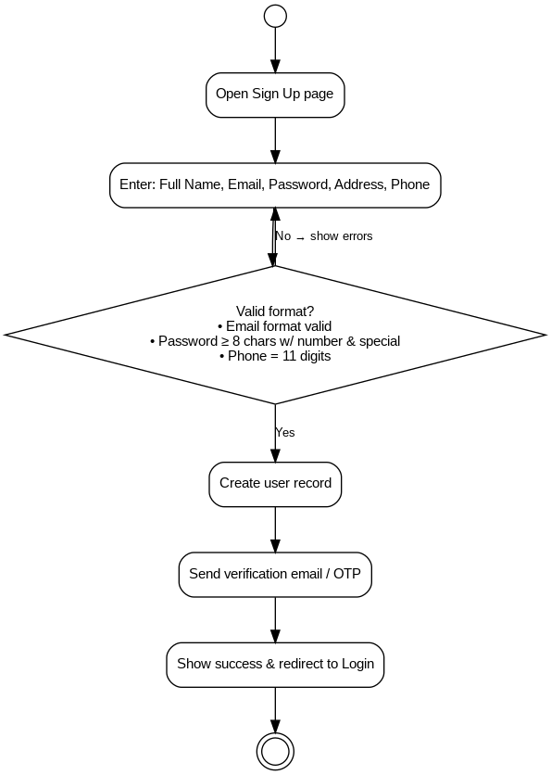

3.2. Use Case 2
ID | UC002
Name | Product Browsing and Ordering
Description | This use case describes how a registered user browses, selects, and places an order for products on the GlowHub platform.
Requirement(s) | FR002
Actor(s) | Registered Customer
Precondition | The user must be logged into their account. Products and categories must be available in the system.
Postcondition | The order is successfully created and recorded in the database. The user receives a confirmation message and order tracking ID.

Basic Flow
- The user logs in to GlowHub.
- The user navigates to the product catalog.
- The user browses products by brand, category, or keyword.
- The user views product details such as price (in PKR), description, reviews, and availability.
- The user adds desired items to the shopping cart.
- The system updates the cart and displays the total price.
- The user proceeds to checkout.
- The user enters shipping address and selects payment method (EasyPaisa, JazzCash, Credit/Debit Card).
- The system processes payment securely through the integrated gateway.
- Upon successful payment, the order is created.
- The user receives confirmation via email/SMS including order ID and estimated delivery time.

Alternative Flow
- If the product is out of stock, the user can place a pre-order request.
- The system marks the order as “Pre-order” and sends an estimated delivery date once stock is available.

Exceptions
- Payment transaction failure.
- Network disruption during checkout.
- Product out of stock or discontinued after cart addition.

Diagram
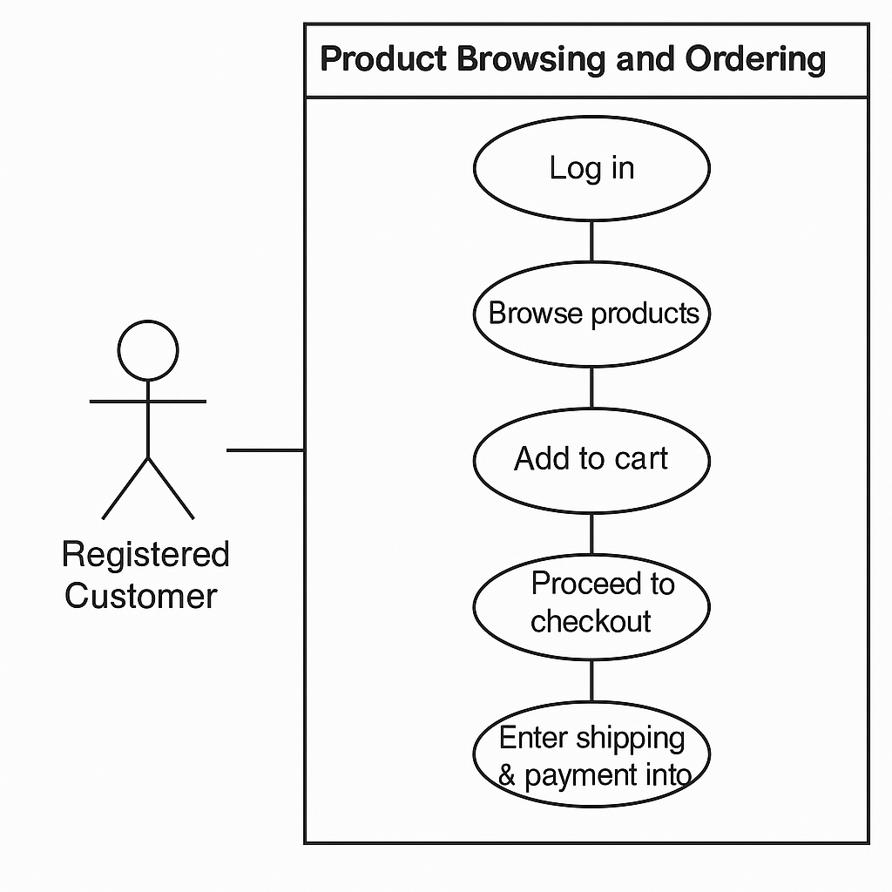

3.3. Use Case 3
ID | UC003
Name | Admin Product Management
Description | This use case describes how the administrator manages products, categories, and stock within the GlowHub system.
Requirement(s) | FR003
Actor(s) | Administrator
Precondition | Admin must be logged in using valid credentials.
Postcondition | Product database is updated successfully, reflecting new, edited, or deleted entries.

Basic Flow
- Admin logs into the secure backend dashboard.
- Admin navigates to the “Manage Products” section.
- Admin selects one of the available actions: Add, Edit, or Delete Product.
- For new product addition, admin provides details:
4.1. Product Name
4.2. Brand Name
4.3. Category (Makeup, Skincare, Fragrance, etc.)
4.4. Price (in PKR)
4.5. Stock Quantity
4.6. Product Description and Images
- System validates data and updates the database.
- Confirmation message is displayed.
- Updated product becomes visible to customers on the storefront.

Alternative Flow
- Admin can bulk-upload product data using an Excel or CSV file.
- Admin can temporarily deactivate a product instead of deleting it.

Exceptions
- Invalid product data (missing name or price).
- Database connection errors.
- Image upload failure.

Diagram
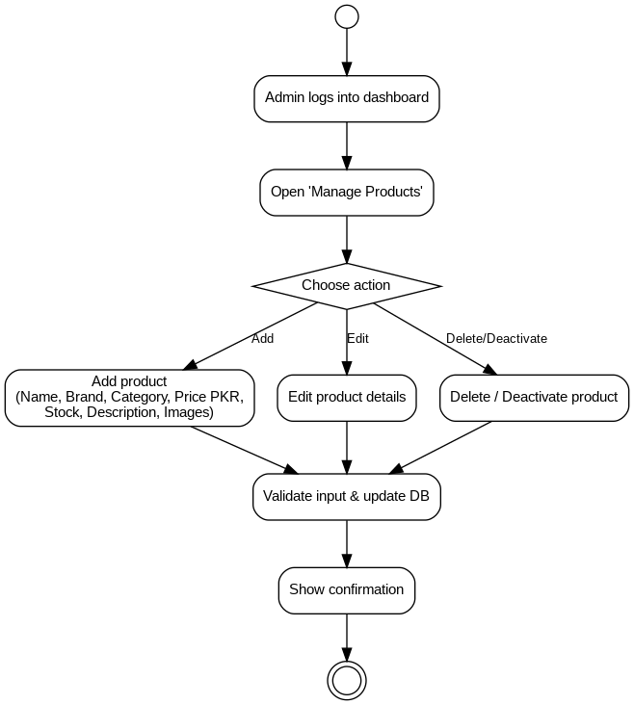

4: References

Pressman, R. S. (2020). Software engineering: A practitioner’s approach (8th ed.). McGraw-Hill Education.
Sommerville, I. (2019). Software engineering (10th ed.). Pearson Education.
Ministry of Commerce. (2023). Pakistan e-commerce annual report. Government of Pakistan. Retrieved from https://www.commerce.gov.pk
Sephora. (n.d.). Official website. Retrieved December 5, 2025, from https://www.sephora.com
Daraz.pk. (n.d.). Online shopping in Pakistan. Retrieved December 5, 2025, from https://www.daraz.pk
Beautify by Amna. (n.d.). Official store. Retrieved December 5, 2025, from https://www.beautifybyamna.com
Telenor Microfinance Bank. (n.d.). Easypaisa developer documentation. Retrieved December 5, 2025, from https://developer.easypaisa.com.pk
JazzCash. (n.d.). Developer portal. Retrieved December 5, 2025, from https://developer.jazzcash.com.pk

